TechConnect

Locaberte, Leynard A.

Miranda, Abegail C.

Endozo, Jasmine S.

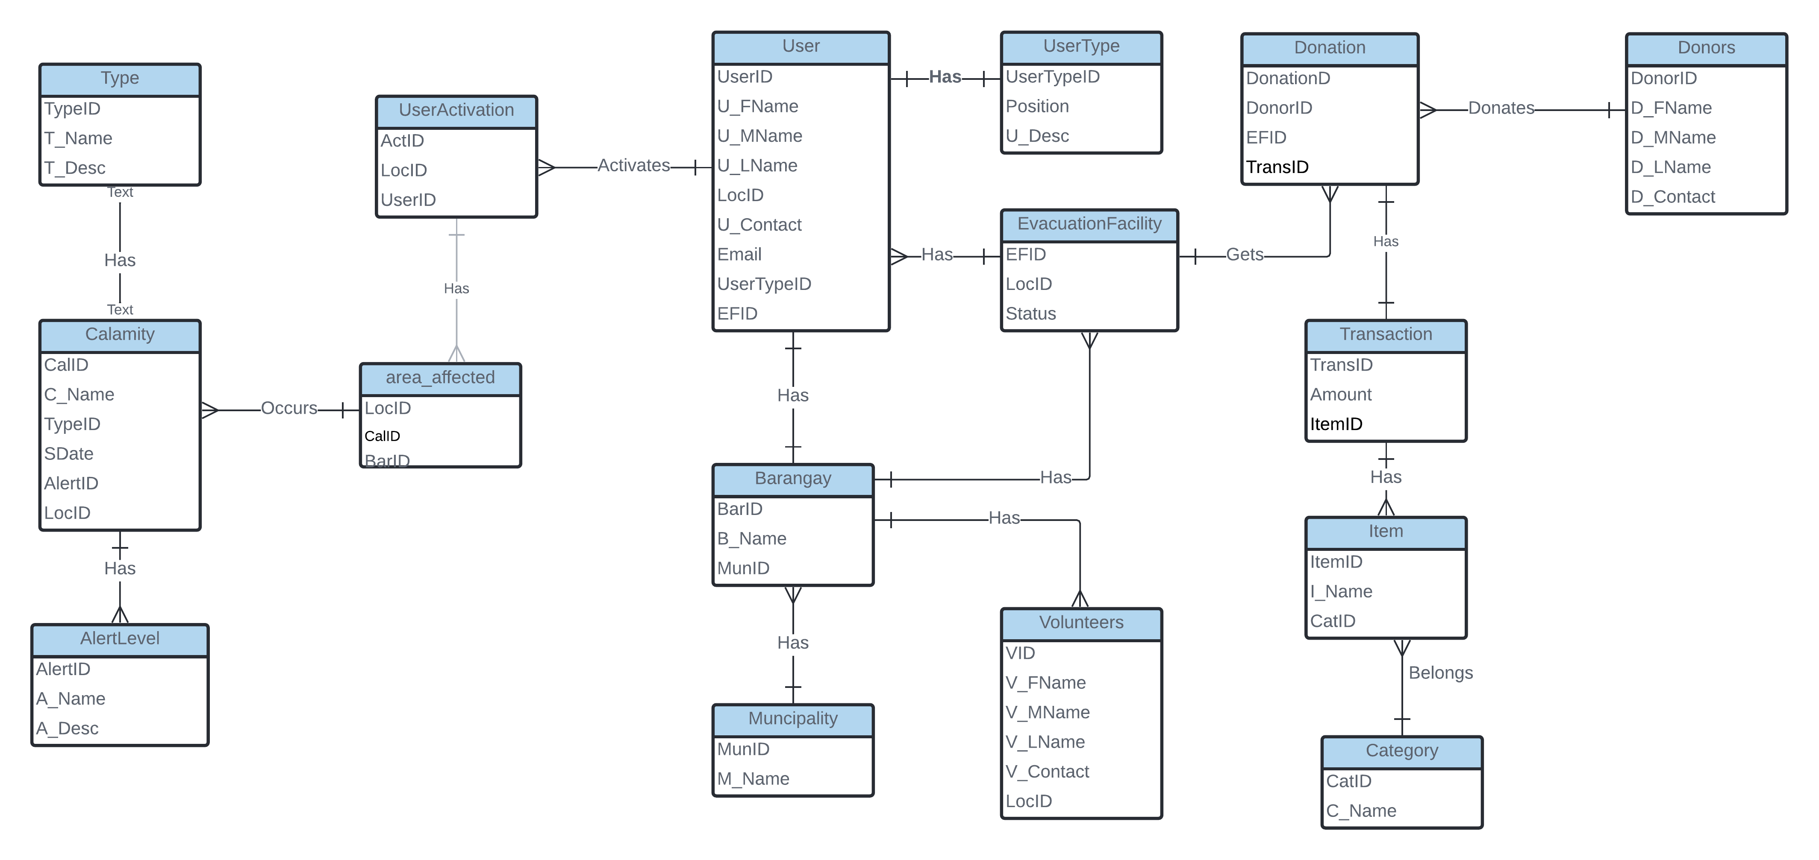

SELECT * FROM `tulongkabatang`.`municipality` WHERE `M_Name` = 'Agoncillo'

SELECT * FROM `barangays` WHERE MunID = 1

SELECT * FROM `transaction` WHERE CatID = 1

[SELECT](http://localhost:8080/phpmyadmin/url.php?url=https://dev.mysql.com/doc/refman/5.5/en/select.html) * FROM `user`

[SELECT](http://localhost:8080/phpmyadmin/url.php?url=https://dev.mysql.com/doc/refman/5.5/en/select.html) * FROM `user` WHERE Location = Nasugbu

[SELECT](http://localhost:8080/phpmyadmin/url.php?url=https://dev.mysql.com/doc/refman/5.5/en/select.html) * FROM `evacuationfacility’ WHERE Location = Nasugbu